Vaughan Turekian

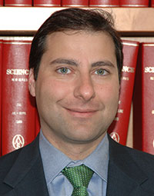
Vaughan Turekian
Chief International Officer
American Association for the Advancement of Science
Area(s) of expertise: International issues, clean energy, sustainable development, climate change, scientific cooperation, avian influenza
Language(s) spoken: English
Contact Information:
202-326-6650
vturekia@aaas.org
Home Page: www.aaas.org
More information: www.aaas.org/programs/international
PIO Contact: Earl Lane
202-326-6431
elane@aaas.org
American Association for the Advancement of Science
Dr. Vaughan Turekian is Chief International Officer for the American Association for the Advancement of Science (AAAS). In this role, he leads, develops and coordinates the broad range of AAAS's international activities. Prior to this position, Dr. Turekian served as Special Assistant to the Under Secretary of State for Democracy and Global Affairs, where he was lead advisor on international science, technology, environment and health issues, including, clean energy, sustainable development, climate change, scientific outreach and avian influenza. He is the two-time recipient of the Department's Superior Honor Award for his work on climate change and avian influenza.
Prior to his time at the State Department, Dr. Turekian worked at the National Academy of Sciences (NAS). In 2001, he was the Study Director for the White House-requested NAS report on climate change science. He has published numerous articles on the linkages between science and international policy. Dr. Turekian received his master's and PhD in atmospheric geochemistry from the University of Virginia, where he focused on applying stable isotopic tracers to characterize aerosol sources and chemistry in the marine boundary layer, and was awarded the Maury Prize as Outstanding Student in Environmental Sciences. He is a graduate of Yale University with degrees in geology and geophysics and international studies

