Henry Roman

Chairman, WAYS-Africa / Royal Abacus Manager
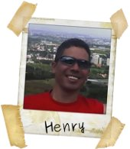
Henry Roman is a former student of the Nelson Mandela Metropolitan University (MSc Biochemistry) and Rhodes University (PhD Biotechnology), both in the Eastern Cape, South Africa. In 2005 he started a post-doc in the division Biosciences, CSIR, South Africa. He left the CSIR as a Projects Manager in 2008 to join Metago Engineering Services, an environmental consultancy as a Scientist. Henry has an active interest in the bioremediation of acid mine drainage, and the environmental health of South Africa's water resources.
In 2007 he was elected Chairperson of WAYS Africa. He currently serves on the Management Committee of the Young Water Professionals of Southern Africa and is a registered professional scientist with SACNASP.

