Marin Dacos

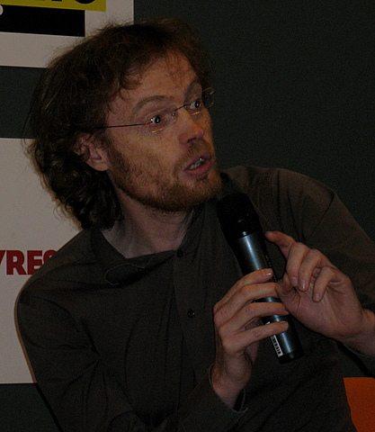
Background
Mr. Marin Dacos is a digital humanities specialist who is currently the director of the Centre of Open Electronic Publishing (Cleo) as well as an information systems manager for National Centre for Scientific Research (CNRS) located in France. Furthermore, he is the founder of several initiatives such as Revues.org, Lodel, Calenda, and Hypotheses which will be discussed in the session overview. Mr. Dacos investigates how Revues.org and PKP can be used to improve manuscript management tools and document conversion.

