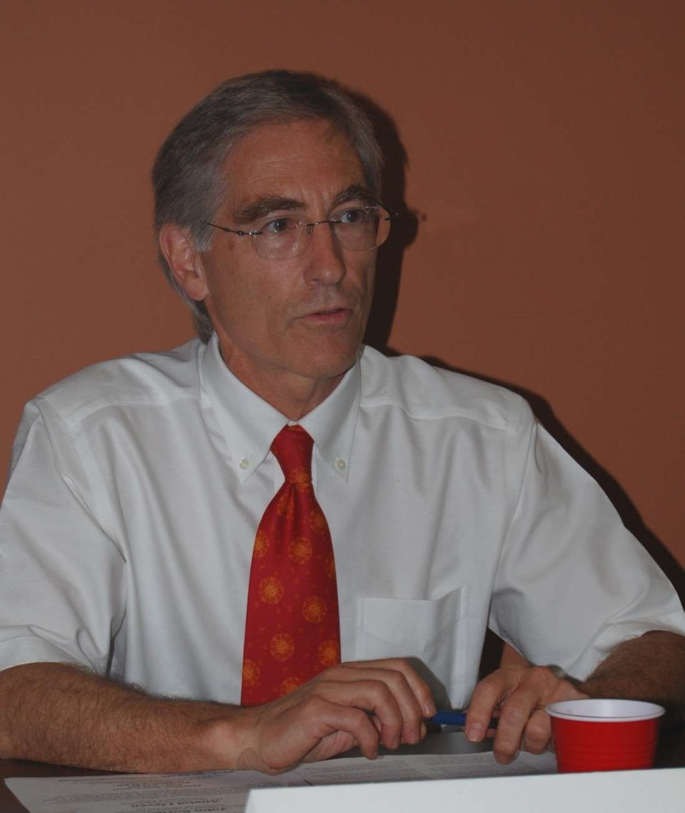
John Phillips Boright
Executive Director, Office of International
National Academy of Sciences, USA

 Educational Background

B.A. Physics, Cornell University, 1965
Ph.D. Physics, Cornell University, 1970

 Professional Experience

1995 – Present Executive Director/International Affairs, US National Academy of Sciences
1993 – 1995 Assistant Director for Security and Int'l Affairs, Office of Science and Technology Policy,
Executive Office, White House
1990 – 1993 Deputy Assistant Secretary of State Science and Health Affairs, US State Department
1980 – 1982 Ag. Deputy Assistant Secretary of State Nuclear Affairs, US State Department
1982 – 1986 Counselor, Scientific Affairs, American Embassy, Paris
1987 -1989 Director, International Programs, National Science Foundation

 Field of Study

Physics

