Dr. Dong-Pil Min

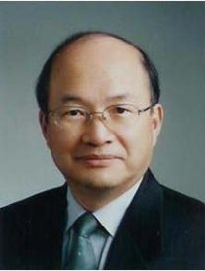
Dr. Dong-Pil Min held the position of Professor of Physics at Seoul National University from 1998-08. In 2008, he became Chairman of the Korea Research Council of Fundamental Science and Technology which includes 13 national research institutes. He has also served as Director of the Information Center for Physics Research (ICPR) in Seoul National University since 1996. He was the Korean representative of C12 for the Int. Union of Physics and Applied Physics (IUPAP), serving untill 2008. He previously held several leadership positions including Vice President of Korean Physical Society and Director General of Korea Research Foundation. He received his PhD and Doctorat d’état in Theoretical Physics from the University of Paris in 1976 and 1980, respectively.

