Prof. Crispus Kiamba
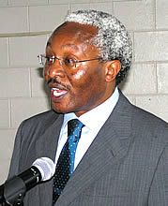
Prof.Crispus Kiamba (Board Chair, Kenya), is the Permanent Secretary of the Ministry of Science and Technology of the Government of Kenya. Previously he was Chief Executive Officer and Commission Secretary of the Commission on Higher Education (Kenya). Prior to that, Prof. Kiamba was the Vice-Chancellor of the University of Nairobi (2001-2004), and at different times been the Deputy Vice-Chancellor (Administration and Finance), Principal of the College of Architecture and Engineering, Dean of the Faculty of Architecture, Design and Development, and Chairman of the Department of Land Development of the same University. He holds a B.A. in Land Economics from the University of Nairobi, an M.Sc. from the University of Reading, and a Ph.D. from the University of Cambridge.
In addition to Twana Twitu, Prof. Kiamba sits on the Boards of several institutions and bodies, including several governing bodies of Kenyan universities; the Kenya National Economic and Social Council (NESC); the National NEPAD Coordinating Committee, and the Nairobi Hospice, just to name a few.

