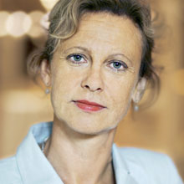

Facts
Ambassador Cecilia Björner
Ambassador Cecilia Björner was born 1959 in Härnösand in Sweden. She graduated in economics and business administration at Uppsala University and holds a Master from Harvard University in USA. Ambassador Björner joined the Swedish foreign service 1991 and has worked as a diplomat in the fields of international development cooperation, UN-affairs, EU-cooperation and Eastern Europe.
Before she joined the MFA she also worked at the Swedish Export Credit Guarantee Board (EKN) and the Swedish International Development Agency (Sida). During her years with the foreign service she has also twice been seconded to the UN.

